1. Call to Order
Meeting was called to order by GK Mike Bullock at 6:30 PM. All officers except Inside Guard, Trustee# 3, Treasurer, and Chaplain were present. The Chaplain was at a meeting at Supreme in CT. The Trustee was traveling, and the Treasurer was ill.
There were nine in person and three online for a total of 12 in attendance.
2. Opening Prayer
Opening prayer was led by GK Mike Bullock
3. Pledge of Allegiance (USA)
Pledge of Allegiance was led by GK Mike Bullock
4. Approve Minutes of Prior Meeting
Amended 11 May minutes were reviewed. Motion made by Ted Barrett to accept the amended minutes as delivered. Motion seconded by Dick Labrecque. No discussion ensued and the minutes were approved.
5. Chaplain’s Message
None. Chaplain was away on other pastoral business.
6. Grand Knights Report
Welcome. I hope you enjoy this evening of Family Bowling!
See the Newsletter that was emailed to you today. (Newsletter done on Website) for past and future events, information of interest, details about Warnings and opportunities to serve.
Next home-cooked dinner 13 July business meeting.
Membership and Retention. Need 8 new members.
Since we are meeting with wives at a bowling party, the financial reports, Membership report, Other reports, State Officer reports, Lecturer's Reflection and Unfinished Business are suspended for this month.
11. New Business (new motions)
The following slate of officers was presented for the next fraternal year. Dick Labrecque motioned that the slate, as presented, be accepted. Motion was seconded by Ted Barrett. Following a point of order from Dick Stevens, the GK called three times for any other nominations. None were proposed.
Dick Stevens then requested that one ballot be cast by the Recorder to accept the slate of officers.
The proposed slate was accepted.
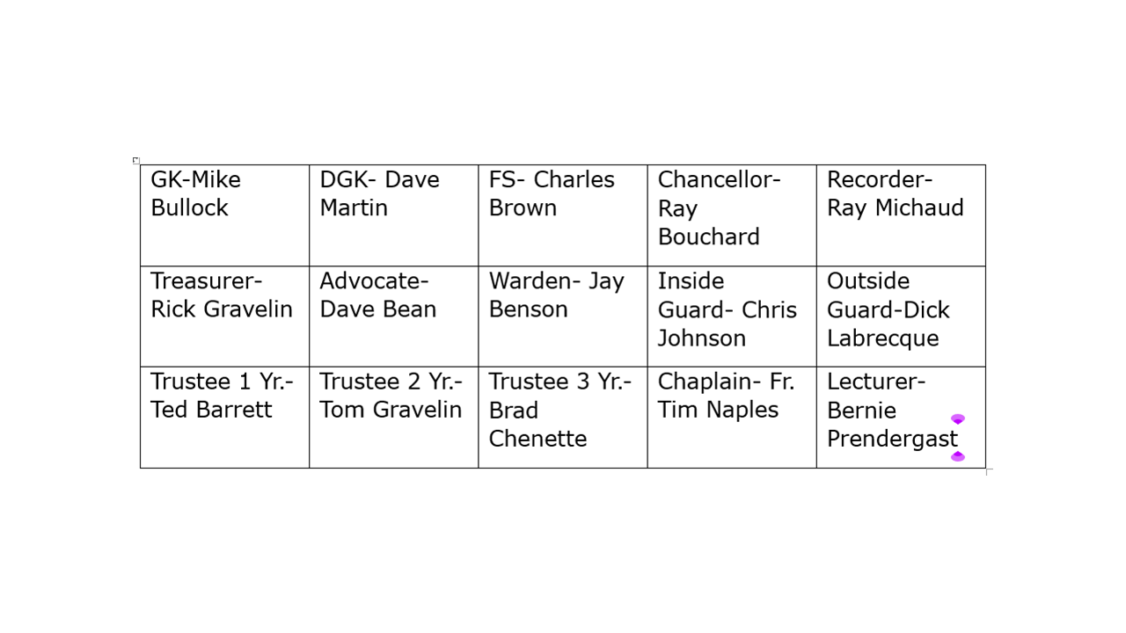
- A special presentation (posthumously) will be made after the 10:30 Mass at St. Catherine's on June 25th making Cullen Bullard an honorary member of the Fourth Degree.
- Bob Wilkens will be returning to Harbor View this weekend.
- Organization arranging a trip for local catholic high school to Steubenville, OH asked what they should do with the extra funds they received for travel expenses. Since neither the council nor its members provided funds for this, the council has no recommendation to make.
- Ted Barrett asked if the list of people and special intentions in our Closing Prayer be updated. After review, we added Susan Sargent, and removed Chris Barrett, Kelly Jackson, Cher Racine, Joe Donegan, Tom and Rick Gravelin, Gary Howe and family, Parker Lyon, Garrett, Ellen and Clara Lyon, and Joe Myers and family. Thank God for all of the answered prayers.
12. Good of the Order
Knight of the Month Award; MAY: REV Timothy Naples

Family of the Month Award; MAY: Dick and Jackie Labrecque
15. Closing Prayer
Susan Sargent, Zak Bigelow, PSD Mike Patnode, Pope Francis, Mrs. Jackie Crosby, An Anonymous Member in distress, Niko Limnos and Family, Most Reverend Christopher Coyne, Mother-in-law of Ronnie Sweet, Bill Curtin, Rev. Msgr. Peter Routhier, William Cannon and Family, Michael Gravelin, Mark and Paulette Noyes and Family (esp. Levi age 5), John O’ Brien, Cheryl Allain, Andy Corologos, Claire Myers and Carol Alfred (cancer), PFN Bill Ladd, PGK Bernie Hemond, Marilyn LeCount, Dick and Sandy Stevens, Beth-Ann Prendergast, Mariette Nadeau, Jeff and Kay Jarvis, Chuck Schifilliti, Gerry Seney, Robert Gravelin, Keith Marston, Sue Cottrell, (22 year old woman fighting cancer at Dana-Farber), Kevin and Chad Limoge, Vickie Linton, George Stevens, James Read, Richard Waite, Gene Tofferi, Mike and Pam Audette, Jeffrey Claude Danis and family, PSD/PGK Don Sutton, PGK Ray Miller, Stuart Fath, Harold Ponto, Wally Rooney, Bob Wilkens, Ed and Theresa Curtiss, one anonymous brother knight, the people of Ukraine and an end to the war, the Families of all of our faithfully departed brothers, friends and relatives, all clergy and religious, victims and families of COVID-19, First Responders, peace in Eastern Europe, that pregnant women will choose life, and for new Members to join the Order.
Pray also for all the victims who have died in the Ukraine War and for Michelle Paquette. May they rest in peace. May all the faithfully departed rest in peace and may their families be comforted by the promise of everlasting life in the Kingdom of Heaven.

Prayer for Canonization of Blessed Michael McGivney was led by GK Mike Bullock.
God, our Father, protector of the poor and defender of the widow and orphan, you called your priest, Blessed Michael McGivney, to be an apostle of Christian family life and to lead the young to the generous service of their neighbor. Through the example of his life and virtue, may we follow your Son, Jesus Christ, more closely, fulfilling his commandment of charity and building up his Body which is the Church. Let the inspiration of your servant prompt us to greater confidence in your love so that we may continue his work of caring for the needy and the outcast. We humbly ask that you glorify Blessed Michael McGivney on earth according to the design of your holy will. Through his intercession, grant the favor I now present (here make your request). Through Christ our Lord. Amen.
16. Adjournment
The meeting was adjourned at 6:55 PM.
Attendance: Including Zoom participants, a total of 12 members attended the meeting.

