1. **​Call to Order**

GK Mike Bullock called the meeting to order at 6:30 PM.

1. **​Opening Prayer**

Worthy Chaplain Tim Naples led attending members in opening prayer. **​**

1. **Pledge of Allegiance (USA)**

GK Mike Bullock led the attending Brothers in the Pledge of Allegiance.

1. **Exemplification**

GK Mike Bullock suspended the business meeting for the conduct of the Exemplification of Charity, Unity, and Fraternity.

Two candidates participated in the exemplification. One candidate, Dcn Gonzalo Cardona, sponsored by Worthy Financial Secretary Ray Michaud, will be a member of Council 7525. A second candidate, a doctor, is a new member of Richmond Council 4684.

After the Exemplification ceremony, GK M. Bullock resumed the business meeting.

1. **Insurance Agent**

Worthy Brother David Guiliani explained the benefits available to the members of the Knights of Columbus.

1. Death Benefits (recently changed to $5K in the event of accidental death for those members both <65 yrs old and members 5 yrs for receiving maximum benefit). For more information, see the K of C website using this link: https://www.kofc.org/en/news-room/knightline/2024/august/order-implements-increases-fraternal-benefits.html.
2. Access to K of C insurance portfolios (death and long-term care)
3. Review of other benefits described in the Form 2772 Member Benefits insert. A copy of the insert is provided as Addendum #1 at the end of these minutes.
4. **​Approval of Minutes from previous business meeting**

Worthy Brother Dick Stevens motioned to approve the August 8th Business Meeting minutes. The motion was seconded by Worthy Deputy Grand Knight (DGK) D. Martin.

Minutes were previously transmitted to all members by email. No changes were made, and the September 12, 2024, minutes were approved. **​**

1. **Chaplain's Message**

The worthy Chaplain yielded his time back to the meeting.

1. **​Grand Knights Report**

The next Holy Hour is Friday, November 1, 2024, at 3 PM.

The next business meeting is on November 14 at 6:30 PM (after chili and cornbread provided by Worth Deputy D. Martin and Worthy Treasurer S. Shover, respectively).

Bingo is on October 17 at 6:30 PM. Workers need to set up at 4:30 PM.

COR Formation is October 19 at 10 AM with coffee and donuts.

Fr. Tim requests help at the annual Cemetery Walk on October 26, 6-9 PM. (Hospitality volunteers should arrive by 5:30 PM. Anyone wanting to be a guide should call Fr. Tim to coordinate additional training and rehearsal.)

Anchor Award for Fr. Yvon Royer on OCT 27 from 4-8 PM at ST Peter's Church in Vergennes. (Free will donations accepted. Details in State Newsletter.)

November 9, Day of Prayer for Clergy from 10-11 AM at St. John Vianney.

1. **Financial Report**

Worthy Financial Secretary (FS) Ray Michaud reported the Morgan Stanley Account Value of $449,315.13 as of October 10. In conjunction with the Worthy Treasurer, the FS provided a paper copy of the spending plan indicating the status of planned payments and unexpected expenses for the past quarter. See Addendum #2 at the end of the minutes for the report.

Worthy Treasurer Steve Shover presented a paper copy of the monthly summary of expenses and incomes for September. The ending balance as of October was $15,710.29. See Addendum #3 at the end of the minutes for the full treasurer's report.

1. **Membership Report**

The recruiting goal for Council 7525 is seven new members for this year (July 1, 2024 – June 30, 2025). The council has officially recruited five new members.

When using the website to register a candidate be sure they validate their email:

Website: <https://www.kofc.org/secure/en/join/join-kofc.html>

Potential candidates must provide their birthdate, email address, phone number, and mailing address.

Enter "BLESSEDMCGIVNEY" to ensure the individual receives the first year of membership for free.

**SPECIAL NOTE:** Per the information provided by State Deputy Chris Poirier during the Council Officer Meeting--once "information to join" is submitted through the website, the applicant will receive an email, and the applicant must respond to the email to validate and complete the application.

**Remember the acronym "CARE"** as part of membership drive efforts. Care stands for Contact, Accompany, Recruit, and Engage. See the Membership Development Model in the October Council Newsletter for more details.

1. **Other Reports**

**Camp Ta Kum Ta**—GK Mike Bullock expressed his appreciation for Faithful Navigator (FN) M. Audette coordinating the procurement of stain needed to refinish the chapel and for the party that gathered at CTKT, (the Chapel 5) who prepped and stained the Chapel on October 8.

**Chittenden County Right to Life Dinner**—GK Mike Bullock praised those who helped with the CCRTL Dinner on September 21 and called out Worthy Warden J. Benson's effort to coordinate, calculate, and purchase the food materials for the meal (excluding the roast beef) and WFN M. Audette for using his chef skills to lead us in the production of a tasty meal.

1. **​Unfinished Business**

**The fryolator initiative**—Worthy Warden J. Benson provided an update on his research and fact-finding mission. He is in communications with D&M Fire and Safety Equipment of Fairfax, VT. He believes it may be prudent to pursue installation and fire suppression upgrades as the exhaust hood is not likely in compliance with frying foods such as bacon on the current stovetop. The upgrade would accommodate the installation of a fryolator. The next step is for a representative of D&M to do an onsite inspection.

**Our Lady of Mount Carmel sign painting project**—GK Mike Bullock recommended postponement till next spring and that it might involve the trimming of a nearby tree.

1. **Other Business**

The next Tootsie Roll campaign will occur next spring, per Worthy Chancellor T. Barrett.

GK Bullock will call a meeting of the website team soon to determine the necessary functions for the Council website.

1. **​New Business (new motions)**

The following was warned for a vote during the business meeting:

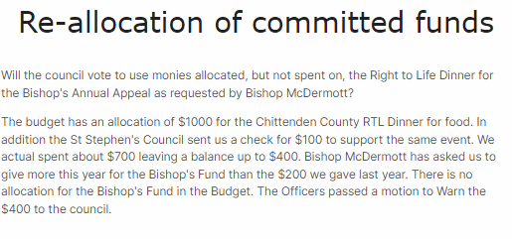Worthy Treasurer Steve Shover motioned to use leftover funds from the CCRTL Dinner and donate $400.00 towards the Bishop's Appeal. Worthy Brother Dick Stevens seconded the motion. Attending members voted on the motion, and the motion passed unanimously.

1. **​Good of the Order**

The following were recognized for their outstanding accomplishments and contributions:

# Knight of the Month for September: WFN Mike Audette Family of the Month for September: Jay and Alice Benson

1. **​Lecturer's Reflection**

Worthy Lecturer Bernie Prendergast spoke to the faith and virtue of St. Pope John 23rd (feast day OCT 11) and sang the song *Our Lady of Knock.*

1. **​Grand Knight's Summary**

Help to make our events in the service of Christ successful. Please answer the call.

If you need something or know someone needing a visit, call one of us or the office.

Please make time to visit our Knights who are ill or shut in.

If you are doing good work, let our Program manager, Ted Barrett, know about it for our Star Council Award. (Take a photo, please)

Use CARE when approaching potential new members. Please consider saying the Holy Rosary Daily.

1. **​Closing Prayer**

Prayer List:

*Robert Morris (GK Bullock's nephew),* Jacobi Roullet, 6 Mo old Great-Grandson of Mike Audette, PGK Louis Lauzon of St Marks, Nathan Cookson, Kenneth Limoge*,* SK Joe Groleau (in hospital), a friend of Fr. Naple's whose daughter was recently diagnosed with leukemia*,* Mike and Pam Audete, Bishop John McDermott, Timothy O'Neill, Fr. Jeremias Tigga, Ben Fine (son-in-law of Ray Michaud), PGK Ray Miller, General success of Catholic Radio, Mason and Elizabeth Bullock, Richard Labrecque, Leonard Robear, Chris Johnson, Arlene Michaud (Ray's sister), Gail Couillard, Marilyn LaCount, Friend of David Gravelin, Anthony Naples, Andre Ricard (Assembly 1157 Newport), Zak Bigelow and family, Pope Francis, Mrs. Jackie Crosby, An anonymous member in distress, Niko Limnos and Family, Mother-in-law of Ronnie Sweet, William Cannon and Family, Michael Gravelin, Mark and Paulette Noyes and Family (esp. Levi age 7), John O' Brien, Cheryl Allain, Claire Myers, Kelly Jackson (daughter of late PGK Jeff Jackson), PGK Bernie Hemond, Dick and Sandy Stevens, Beth-Ann Prendergast, Mariette Nadeau, Jeff and Kay Jarvis, Tom Gravelin, Chuck Schifilliti, Gerry Seney, Robert Gravelin, Keith Marston, Sue Cottrell, (23 year old woman fighting cancer), Kevin and Chad Limoge, Vickie Linton, George Stevens (Assembly 2106), James Read, Gene Tofferi, Jeffrey Claude Danis and family, Stuart Fath, Wally Rooney, Ed and Theresa Curtiss, one anonymous brother knight, the people of Ukraine, Israel, Gaza and an end to the wars. All clergy and religious. All victims and families of COVID-19, Hurricanes Helene and Milton, and flooding. First Responders, police, and firefighters. For a just solution in the Middle East, that pregnant women will choose life and for new members to join the Order.

For all the faithfully departed and their grieving families, especially Kaylea Allenbaugh, 33, granddaughter of Worthy SK Maurice Noel. May she rest in peace and may all the families of the deceased be comforted by the promise of everlasting life in the Kingdom of Heaven.

# Worthy Chaplain T. Naples led attending members in a closing prayer with special intentions for those on the prayer list

# 19. ​Adjournment

GK Bullock adjourned the meeting at 7:54 PM.

Attendance: eighteen members, including five Zoom participants, attended the business meeting. All officers except for Worthy Inside Guard D. Bean were present. The Inside Guard was excused.

**Addendum #1—K of C Member Benefits pamphlet**

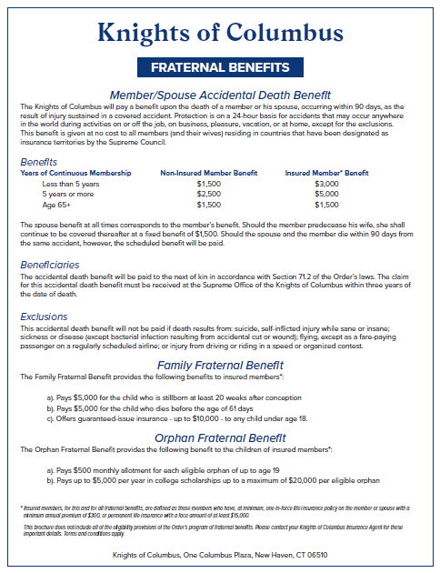

**Addendum #2—Quarterly Spending Plan Report**

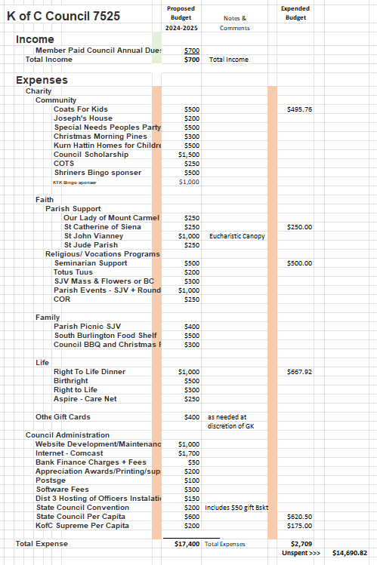

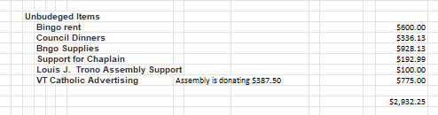

**Addendum #3—**

