- Call to Order
Grand Knight (GK) M. Bullock called the meeting to order at 6:33 PM.
- ​Opening Prayer
GK M. Bullock led the group in saying the “Our Father” prayer.

- ​Pledge of Allegiance (USA)
While facing the American flag, GK M. Bullock led attendees in reciting the Pledge of Allegiance to America.
- ​Approval of Minutes from Prior Meeting
Worthy Brother Dave Martin motioned to approve the meeting minutes from August 14, 2025, which were previously distributed. Worthy Brother Steve Shover seconded the motion. The motion passed unanimously. (Note: each member received the minutes by email before the meeting.)
- Chaplain’s Message

No message, tonight. Worthy Chaplain Fr. T. Naples was absent as he was attending the annual gathering for Aspire Now.
- Grand Knights Report
As always, please read the Council Newsletter and Business Meeting Minutes for additional details.
Big events next month include the Right to Life Dinner on Saturday, September 20, 2025.
Chris Stefanik REBOOT on Wednesday, September 24, 2025. REBOOT has asked for six ushers, and per Mike Pesquale, is also looking for two shuttle van drivers/assistors and ticket takers. If you can help, please let GK M. Bullock know. Ushers need to arrive between 5:30 and 5:45 PM.
There will be St. John Vianney Council Bingo again on September 18.
Spiritual Development for men (Cor Formation) meets again on Monday, September 22, at 6:30 PM. We are all called to be students and evangelists of the Word.
District 3 Officer Installation is on October 2 at 5:30 PM at St. John Vianney Church, followed by dinner. At approximately 6:30 PM, an in-person Council 7525 Officer meeting will take place.
Next Holy Hour is October 3 at 3:00 PM. Come help us by leading a decade of the Rosary.
Save the date notifications for our catered Christmas party on December 14 have gone out.
- Financial Report

Worthy Financial Secretary, R. Michaud, reported that the Morgan Stanley Account value was $489,060.49 as of September 11, 2025.

Worthy Treasurer, S. Shover, provided the Treasurer’s report, which includes the following: As of August 31, 2025, the checking account balance was $21,188.47. A copy of the August treasurer’s report is in Addendum #1, located at the end of these minutes.

The Worthy Treasurer indicated that he would provide additional details on future treasurer reports to clarify the purpose of the check cut, thereby distinguishing between multiple payments to the same recipient.

- Membership Report
GK M. Bullock announced that Worthy Brother R. Fay will receive the Shining Armor Award in part for his recruitment of the first new member for this fiscal year, participating in three or more K of C council events, and attending at least three meetings in his first year of membership. Congratulations Roger!
9. Other Reports
District Deputy (Sir Knight and Worthy FN Mike Audette)
District 3 Officer Installation is on October 2 at 5:30 PM with dinner provided afterwards by Worthy Faithful Navigator (WFN) and Third District Deputy (DD3) Mike Audette. Dress code is sports coat and a collared shirt minimum. Tie not required. DD3 M. Audette expects as many as 70 people to attend, with all three councils being represented.
DD3 Audette emphasized the importance of attendance for COR, noting that Council 7525 is the only council offering this program in the area. It was mentioned that the Supreme and the State Deputy are emphasizing COR and encouraging more COR opportunities and attendance for spiritual growth.
DD3 Audette mentioned the date change for the Anchor Award Ceremony, which is in Newport on October 5.
The next scheduled Fourth Degree Exemplification is scheduled for October 25th at White River Junction. Anyone interested in becoming a Sir Knight should speak to GK M. Bullock or Faithful Navigator M. Audette.
Expect a future change in the recruitment and onboarding process for new members. The change involves a new process using recruitment cards, where the Brother Knight turns in the completed card instead of having the potential recruit sign up online.
Tootsie Roll Campaign: Sir Worthy Brother J. Benson and Worthy Brother Ed Precourt reported the raising of $506.00 from St. Catherine’s Church. This makes the total raised $1,382.00 from the four churches (St. John Vianney, St. Catherine, Our Lady of Mount Carmel, and St. Jude). Twenty percent of the money raised goes to the State, and the remainder will be used for the Special People’s party scheduled for December 13, 2025.
CTKT Super Bingo 40th Annual May 24, 2026
SJV Bingo Committee—Worthy Financial Secretary R. Michaud reported that he had created posters and sent them to specific individuals to be posted at each church.
10. Unfinished Business
OLMC Sign painting. Bill Kaigle of Ye Olde Sign Shop is working on renovating the sign. A temp sign is in place during repairs.
The K of C stone installation needs a bid for completion. GK M. Bullock spoke to Dennis Casey about it, and Dennis said he was at capacity with one truck short. He will let me know if things change. He indicated he might not charge us for the work.

11. New Business
The Officers decided last week that we will consider additional donations to organizations based on recruitment of new members on a case-by-case basis and warn as required.
The Refund Support Vocation Program (RSVP) was discussed. As a reminder, Council 7525 includes RSVP in its annual budget and traditionally adopts a new Seminarian. Attendees voted to support Mr. Anthony Maurice, who is from Barre, VT, and will consider supporting Mr. Loc Van Vo, who is from Vietnam, next year.
Worthy Trustee J. Benson presented a summary report regarding the Council’s 60% Global CATH and 40% fixed assets investment. Worthy Trustee J. Benson said he generated this report using the AI tool, ChatGPT. A copy of the report is posted at the end of this newsletter as Addendum #2.
Worthy Trustee J. Benson also mentioned last call for Council or Assembly members to place orders for shirts, vests, etc. If anyone was interested, they needed to let him know by September 12, as he planned to place the aggregate order with East Coast Printers in Essex the following week.
12. Good of the Order
The following were recognized for their service and sustained contributions for August:
Knight of the Month: WDGK Dave Martin
Family of the Month: SK Doan and Tram Vu
13. Lecturer’s Reflection
Worthy Lecturer Bernie Prendergast was travelling and did not attend this evening’s business meeting; so, the lecture involving lessons of St Padre Pio and the song Let There Be Peace on Earth is postponed till October’s business meeting.

14. Grand Knight's Summary
BLUF: (Bottom Line Up Front!) We need your help to make our events in the service of Christ successful. Will you answer the call?
If you need something or know of someone needing a visit, call one of us or call the office.
Make time to visit our Knights who are ill or shut in.
If you are doing good work, let our Program manager, Ted Barrett know about it for our Star Council Award. (Take a photo, please)
Use CARE when approaching potential new members.
Please consider saying the Holy Rosary Daily. (A spiritual weapon to defeat evil and convert sinners)
15. Closing Prayer
Council prayer list.

Jim Clark (deploying soon), and for all victims of violence, especially those at Annunciation Catholic Church, David Mangan (friend of GK), George Krol (Father of Alice Benson), Diane Mitchell, Patti Hallam (Parkinson’s), Gail Ponto (broken ankle), newest Vermont Priest Rev Father Joseph Luan Van Tran, William (Bill) Bessette and Family, Terri Lavalee and Family, Pope Leo XIV, Amy Rushford, Kay and Ken Jarvis, David Bean, Richard Labrecque, WSD Chris Poirier, Patrick Anderson, Bruce O’Neill, John (Jack) Romanoski, Lois Fontaine, Barbara Chenette (mother of Brad Chenette), Fr. Naples, Tom F., PGK Louis Lauzon, of St Marks, Nathan Cookson, Kenneth Limoge, SK Joe Groleau (in hospital), Abigail Jackson (leukemia), Bishop John McDermott, Timothy O'Neill, Ben Fine (son-in-law of Ray Michaud), PGK Ray Miller, General success of Catholic Radio, Mason and Elizabeth Bullock, Leonard Robear, Chris Johnson, Arlene Michaud (Ray's sister), Gail Couillard, Marilyn LaCount, Friend of David Gravelin, Anthony Naples, Andre Ricard (Assembly 1157 Newport), Zak Bigelow and family, Mrs. Jackie Crosby, Niko Limnos and Family, Mother-in-law of Ronnie Sweet, William Cannon and Family, Michael Gravelin, Mark and Paulette Noyes and Family, John O'Brien, Cheryl Allain, Claire Myers, Kelly Jackson (daughter of late PGK Jeff Jackson), Dick and Sandy Stevens, Beth-Ann Prendergast, Mariette Nadeau, Chuck Schifilliti, Gerry Seney, Robert Gravelin, Keith Marston, Sue Cottrell, (23 year old woman fighting cancer), Chad Limoge, Vickie Linton, James Read, Gene Tofferi, Jeffrey Claude Danis and family, Stuart Fath, Wally Rooney, two anonymous brother knights, the people of Ukraine, Israel, Gaza, and an end to the wars. All clergy and religious. All victims and families of COVID-19, hurricanes, and flooding. First Responders, police, and firefighters. For a just solution in the Middle East. That pregnant women will choose life. For new members to join the Order.

For the repose of Charlie Kirk, and the souls of those who were victims of violence (particularly those of political violence and attacks on those who are most vulnerable), Celia Asbel, Sue Victory, Fletcher Merkel, age 8, and Harper Moyski, age 10 in Minneapolis, Doug Taff, Levi, and Jeannette Noyes, and their families. For all the faithfully departed and their grieving families. May they rest in peace, and may all the families of the deceased be comforted by the promise of everlasting life in the Kingdom of Heaven.

GK M. Bullock led the council members in the closing prayer, using the Prayer for the Canonization of Blessed Michael McGivney and remembering those on the council's prayer list.

Prayer for the Canonization of Blessed Michael McGivney
God, our Father, protector of the poor and defender of the widow and orphan, you called your priest, Blessed Michael McGivney, to be an apostle of Christian family life and to lead the young to the generous service of their neighbor. Through the example of his life and virtue, may we follow your Son, Jesus Christ, more closely, fulfilling his commandment of charity and building up his Body, which is the Church. Let the inspiration of your servant prompt us to greater confidence in your love so that we may continue his work of caring for the needy and the outcast. We humbly ask that you glorify Blessed Michael McGivney on earth according to the design of your holy will. Through his intercession, grant the favor I now present (our sick or in distress). Through Christ our Lord. Amen.
16. Adjournment
GK M. Bullock announced the meeting adjourned at 7:43 PM.
Attendance: Fifteen members attended the business meeting, including one participant joining via Zoom. All officers except Worthy Lecturer B. Prendergast, Worthy Chaplain T. Naples, Worthy Inside Guard Roger Fay, Worthy Trustee T. Gravelin, and Worthy Advocate R. Miller were present. All absent officers were excused unless otherwise stipulated.

Addendum #1
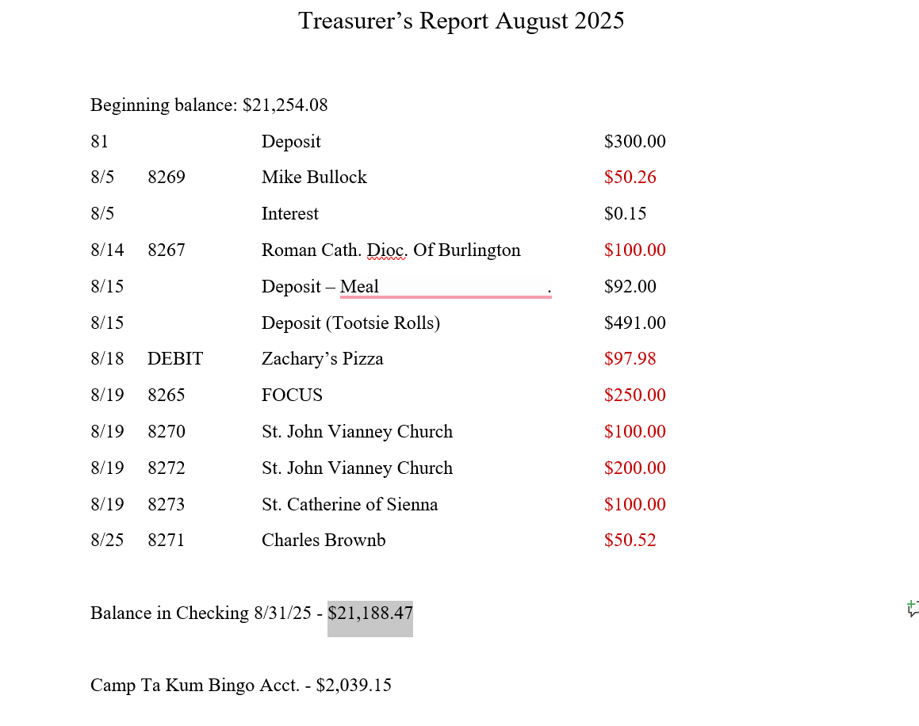

Addendum #2 – ChatGPT Analysis
